Returns And Reverse Logistics
UX Mockups and Interaction Specification
Document owner | Version | Date | Status
Michael Yaacoub, Sr Solution Engineer | 1.0 | 2026-08-24 | Draft

This template follows the sample UX pack: each SCR screen pairs a visual mockup with a specification panel, and the pack closes with a navigation-flow map.

1. Experience Overview
The primary user is a returns operative at an intake bay or a grading bench, working at speed through a trolley of boxes, wearing gloves, with a scanner in one hand. Supervisors and finance analysts work the same records from a desk. Design principles: scanning leads and typing is the fallback; the grading criteria are on screen at the moment of decision, not on a laminated card behind the bench; an unmatched return is a queue to be worked rather than a dead end; and any pending posting is stated plainly rather than shown as complete.
Persona | Primary goal | Device / viewport | Usage context
Returns operative | Receive, grade and route a trolley of returns accurately at speed | Dock handheld and grading bench tablet, 6 and 10 inch | Returns dock and grading bench, gloved, high volume, intermittent coverage at the bays
Finance analyst | Authorise refunds that match what was received and reconcile them to the order | Web, 1440 pixels and wider | Finance office, working many refund proposals in a sitting

2. Screen Inventory
Screen ID | Screen name | Mapped feature | User goal | Primary action
SCR-01 | Return Receipt and Matching | FEAT-01 | Book the return in against its order | Receive the return
SCR-02 | Condition Grading | FEAT-02 | Grade consistently, with the criteria in front of you | Save the grade
SCR-03 | Disposition Routing | FEAT-03 | Send the item where policy says it should go | Action the disposition
SCR-04 | Refund Authorisation | FEAT-04 | Refund what actually came back | Authorise the refund

3. Screen Mockups and Specifications

3.1 SCR-01 Return Receipt and Matching
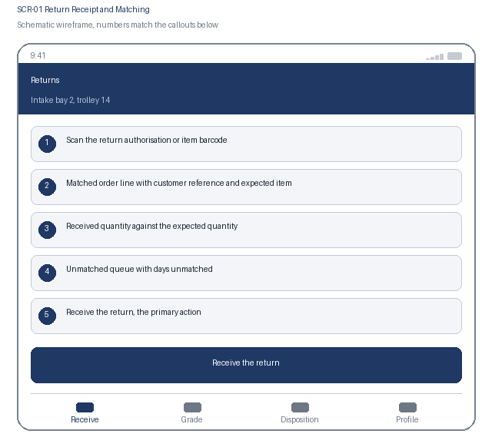  1. Scan the return authorisation or item barcode  2. Matched order line with customer reference and expected item  3. Received quantity against the expected quantity  4. Unmatched queue with days unmatched  5. Receive the return, the primary action | Specification panel  Purpose: The operative books each return in at the dock and it is matched to its original order line, or placed in an explicit unmatched queue.  Primary action: Receive the return, which records the receipt against the matched line or the unmatched queue.  Data: Return authorisation or barcode, matched order and line, customer reference, expected and received quantity, receipt time and bay. Source: returns service over the order management system. No payment card data is present in this payload.  States: Scanning, matched, no match found, unmatched queued, quantity mismatch, offline  Roles: Operatives receive; supervisor works the unmatched queue; finance reads  Requirements: US-101, US-102, NFR-001, NFR-004, NFR-007

3.2 SCR-01 Interaction Details
Element / callout | Behavior | Validation | Accessibility
1. Scan action | Reads the return authorisation or item barcode and resolves the order line | An unreadable or unknown code offers manual search, and failing that receipt as unmatched | Manual entry always available; the match result is announced with the order reference
2. Received quantity | Numeric entry defaulted to the expected quantity | Must be greater than zero; a quantity above the expected requires supervisor confirmation | Visible label, numeric keyboard hint, assertive error naming the field and the expected value
3. Unmatched queue | Lists returns received without a match, oldest first | A return matched later preserves its original receipt date, which is stated when matching | Days unmatched is stated as text per row so ageing is never conveyed by colour alone
4. Receive the return | Records the receipt and moves the item to grading | Blocked while the received quantity is missing; an unmatched receipt requires a reason category | The unmatched outcome is announced clearly so it is never mistaken for a successful match

3.3 SCR-02 Condition Grading
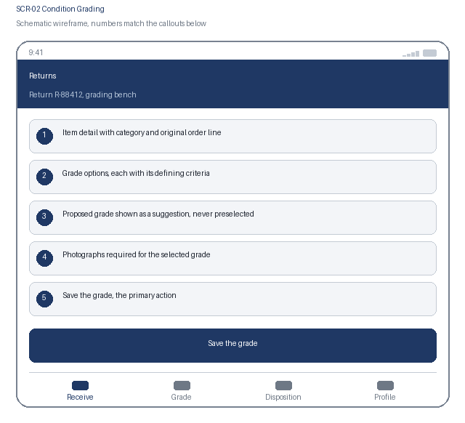  1. Item detail with category and original order line  2. Grade options, each with its defining criteria  3. Proposed grade shown as a suggestion, never preselected  4. Photographs required for the selected grade  5. Save the grade, the primary action | Specification panel  Purpose: The operative grades the item against the defined scale with the criteria for each grade visible, and captures the evidence that grade requires.  Primary action: Save the grade, which fixes the grade and triggers disposition routing.  Data: Item description and category, original order line, grade options with criteria and required evidence, proposed grade with matched criteria, captured photographs. Source: returns service and the grade proposal workflow.  States: Awaiting grade, proposal offered, grade selected, evidence outstanding, saved, under review  Roles: Operatives grade; supervisor reviews and may overturn; finance reads the grade  Requirements: US-201, US-202, NFR-003, NFR-005, NFR-006

3.4 SCR-02 Interaction Details
Element / callout | Behavior | Validation | Accessibility
1. Grade option | Each option shows its defining criteria and the evidence it requires | A grade cannot be selected without its criteria being displayed first | Radio group where each option's accessible name includes the grade and its key criterion
2. Grade proposal | Shows a suggested grade with the criteria it matched, never preselected | The proposal is advisory; the operative must actively select a grade for it to apply | Announced as a suggestion so it is never read as a decision already made
3. Evidence capture | Opens the camera for the photographs the selected grade requires | Every required photograph is mandatory before saving, and the outstanding ones are named | The requirement is stated before capture; each thumbnail prompts for a short description
4. Save the grade | Fixes the grade and passes the item to disposition routing | Blocked while any required photograph is missing, with each outstanding item listed | Confirmation states that the grade determines both the refund and the disposition

3.5 SCR-03 Disposition Routing
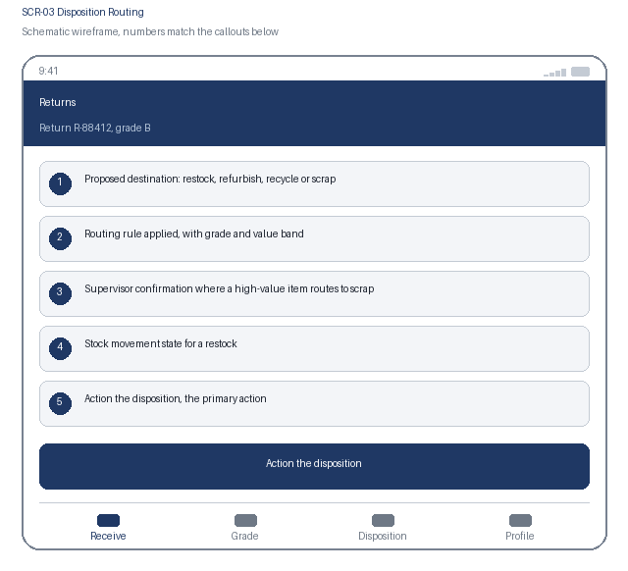  1. Proposed destination: restock, refurbish, recycle or scrap  2. Routing rule applied, with grade and value band  3. Supervisor confirmation where a high-value item routes to scrap  4. Stock movement state for a restock  5. Action the disposition, the primary action | Specification panel  Purpose: The graded item is routed by policy rather than judgement, and a restock returns the unit to sellable stock as the disposition is actioned.  Primary action: Action the disposition, which moves the unit and posts any stock movement exactly once.  Data: Proposed destination, routing rule identifier, grade, item value band, product policy, stock movement reference and state. Source: disposition rules engine and the posting adapter.  States: Proposed, awaiting supervisor confirmation, actioned, stock movement pending, movement failed and queued, complete  Roles: Operatives action; supervisor confirms high-value scrap; inventory manager reads  Requirements: US-301, US-302, NFR-006, NFR-007

3.6 SCR-03 Interaction Details
Element / callout | Behavior | Validation | Accessibility
1. Routing explanation | Expands to show the rule, the grade and the value band that produced the destination | None | Disclosure with expanded state announced; the rule is stated in plain language, not by code
2. Supervisor confirmation | Required where a high-value item would be scrapped | The action is blocked until a supervisor confirms, and the confirming supervisor is recorded | The block explains why confirmation is required rather than presenting a disabled control
3. Stock movement state | Shows whether the restock posted, is pending or failed | A pending or failed movement leaves the return incomplete rather than showing it as done | The state is announced through a polite live region as it resolves
4. Action the disposition | Moves the unit and posts the stock movement where required | Blocked while confirmation is outstanding; a posting failure holds the unit in pending and alerts the supervisor | Confirmation names the destination in plain words before actioning

3.7 SCR-04 Refund Authorisation
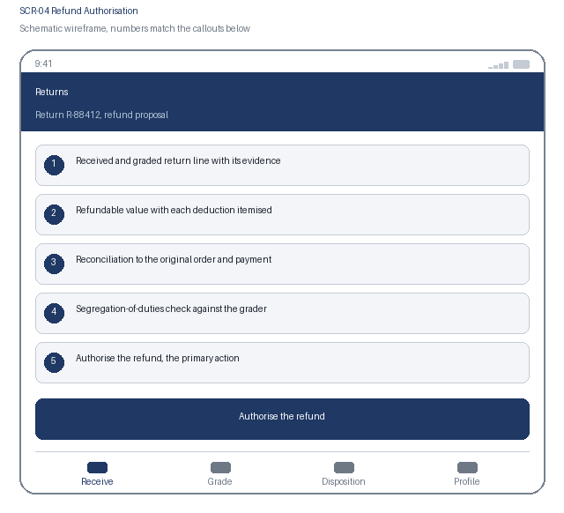  1. Received and graded return line with its evidence  2. Refundable value with each deduction itemised  3. Reconciliation to the original order and payment  4. Segregation-of-duties check against the grader  5. Authorise the refund, the primary action | Specification panel  Purpose: The finance analyst reviews a refund calculated from what was received and graded, and a second person authorises it before it reaches the customer.  Primary action: Authorise the refund, which writes the immutable record and posts the refund exactly once.  Data: Received quantity, grade and evidence, original order line value, refundable value, itemised deductions, original payment reference, grader and authoriser identity, segregation result, posting reference. Source: returns service and order management. No card data is present.  States: Proposed, blocked by segregation of duties, authorised, posting in progress, posted, posting failed and queued, rejected  Roles: Analyst proposes; a different controller authorises; auditor reads the posted record  Requirements: US-401, US-402, NFR-004, NFR-006, NFR-007

3.8 SCR-04 Interaction Details
Element / callout | Behavior | Validation | Accessibility
1. Deduction breakdown | Itemises each deduction against the original order line value | No figure is editable here; a disputed grade must be reviewed on SCR-02 and the proposal recalculated | The breakdown reads as a table with headers, and the total is announced
2. Grading evidence | Opens the photographs the grade was based on | None | Each image carries alternative text naming the item and the grade applied
3. Segregation check | Evaluated server side when the screen opens | If the authoriser graded the return, authorisation is blocked and alternatives are offered | The block explains why in plain language rather than as a permission error
4. Authorise the refund | Writes the record and posts the refund to order management | Blocked while the return is unmatched or ungraded; a posting failure holds the refund as authorised and not posted with the replay state shown | Confirmation states plainly that an authorised refund reaches a customer and cannot be undone

4. Navigation Flow
From | User action / condition | To | Alternate or error path
SCR-01 | Operative receives a matched return | SCR-02 | No match found: the return is received as unmatched and stays in the unmatched queue on SCR-01
SCR-02 | Operative saves the grade with its evidence | SCR-03 | Grade disputed later: supervisor review returns to SCR-02 and both grades are retained
SCR-03 | Disposition actioned and any stock movement posts | SCR-04 | Movement fails or supervisor confirmation is outstanding: the unit holds in pending on SCR-03
SCR-04 | A second authoriser authorises and the refund posts | SCR-01 for the next return | Segregation of duties blocks authorisation, or posting fails and the refund holds as authorised and not posted
Flow: SCR-01 Return Receipt and Matching, receive, to SCR-02 Condition Grading, save the grade, to SCR-03 Disposition Routing, action, to SCR-04 Refund Authorisation for the finance team, and back to SCR-01 for the next return. An unmatched return stays in the unmatched queue on SCR-01 until it is matched, and the bottom tab bar reaches Receive, Grade, Disposition and Profile.

5. Responsive Behavior
Viewport | Navigation | Layout | Content priority | Interaction changes
Phone | Bottom tab bar with four primary destinations | Single column, cards stacked in priority order | Scan target and matched order line first; item history below | One-handed reach with the scan trigger reachable without changing grip; no swipe-only path
Tablet | Adaptive left navigation rail | Return list beside the selected return's grading detail | Primary list beside the selected item's detail panel | Touch and pointer both supported; hover reveals nothing essential
Web | Persistent left navigation with breadcrumbs | Intake queue, grading detail and refund proposals in three columns | Dense scanning of many records, with full detail on selection | Full keyboard support with shortcuts for authorise and reject; no hover-only affordance

6. States and Content
State | Trigger | Displayed content | Available actions
Loading | A data request is still in flight after 300 ms | Skeleton content preserving the final layout, with the scan target enabled immediately | Scanning continues; nothing blocks on a pending read
Empty | A filter, search or assignment returns no records | A plain statement that no returns match, naming the active filter | Clear the filter, or switch to the unmatched queue
Error | A request fails, times out, or is rejected by policy | What failed and whether the receipt or grading was kept, which is stated first | Retry, with captured receipts and gradings always preserved locally
Offline | The device loses network connectivity | A persistent offline banner and a count of receipts and gradings waiting to sync | Receiving and grading continue; disposition posting and refunds queue and confirm after sync

7. Accessibility Requirements
- WCAG 2.2 AA is the conformance target for every screen, including all interactive states and error messaging.
- Every control is reachable in a logical tab order with a visible focus indicator, a programmatic label, and instructions announced before the input rather than only after an error.
- Errors are announced through an assertive live region, name the field, and describe how to correct the problem.
- Text contrast is at least 4.5 to 1 and non-text indicators at least 3 to 1; the interface remains usable at 200 percent text resize and at 320 CSS pixels wide.
- Motion is limited and honours the reduced-motion preference; no information is conveyed by colour alone.
- Touch targets are at least 44 by 44 CSS pixels with adequate spacing, so the interface stays usable with gloves or one hand.
- {Keyboard order, visible focus, labels, instructions, and error announcement behavior}
- {Contrast, text resize, reduced motion, screen-reader, and touch-target expectations}

8. Review and Approval
Reviewer | Role | Decision | Comments | Date
Design lead | UX design authority | Pending | Interaction model and visual specification
Accessibility specialist | Accessibility | Pending | WCAG 2.2 AA conformance evidence
Product owner | Business product owner | Pending | Screen inventory and flow confirmation

